Narrative Report

**June - July 2023**

| ***Partner*** | Power IT |
| --- | --- |
| ***Intervention*** | Skills Development |
| ***Initiative*** | Learn IT and Do IT Learning and Job Mediation Platforms |

23 Courses were successfully elaborated and digitalized.

| Course | Course Registration Statistics (242 person) |
| --- | --- |
| 1. HTML & CSS | 48 |
| 2. JavaScript | 55 |
| 3. React Basic | 8 |
| 4. Python - Basic | 11 |
| 5. SQL - Introduction to SQL with  MySQL | 15 |
| 6. Java Core | 34 |
| 7. Java Spring | 24 |
| 8. PHP Core | 6 |
| 9. QA Automation Verification and Test of Software Products | 14 |
| 10. Manual Software Testing | 13 |
| 11. Applying Agile | 5 |
| 12. Understanding Agile | 4 |
| 13. Agile Project Management | 16 |
| 14. SCRUM | 11 |
| 15. Figma Advanced | 7 |
| 16. Basic Figma | 24 |
| 17. Communicating with Impact | 3 |
| 18. Leadership & Negotiations | 2 |
| 19. Problem Solving & Creativity | 2 |
| 20. Public Speaking | 3 |
| 21. Project Management | 16 |
| 22. Learn High | 6 |
| 23. DevOps basic concepts | 6 |

1. **General overview /Progress:**

In January to July 2023, we actively supported our students on the LearnIT platform. During this period, we received numerous applications for participation in the PowerIT internship program from young students.

Additionally, we organized meetings with people interested in the IT field to provide support and guidance.

1. **Conclusions / future activities**
2. **Annexes 01.07.2022 - 30.03.2023**

Report **Learnit**

Number of users all over the platform – 270

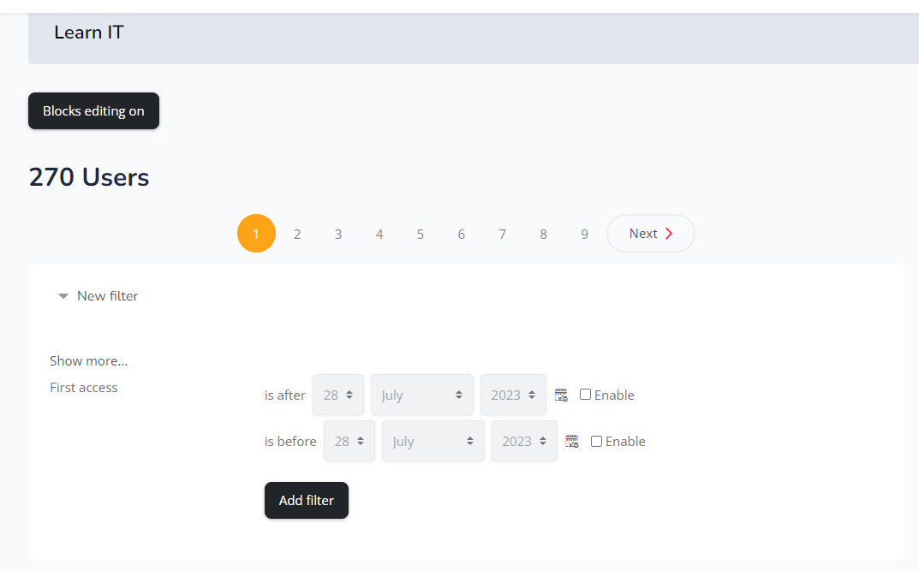

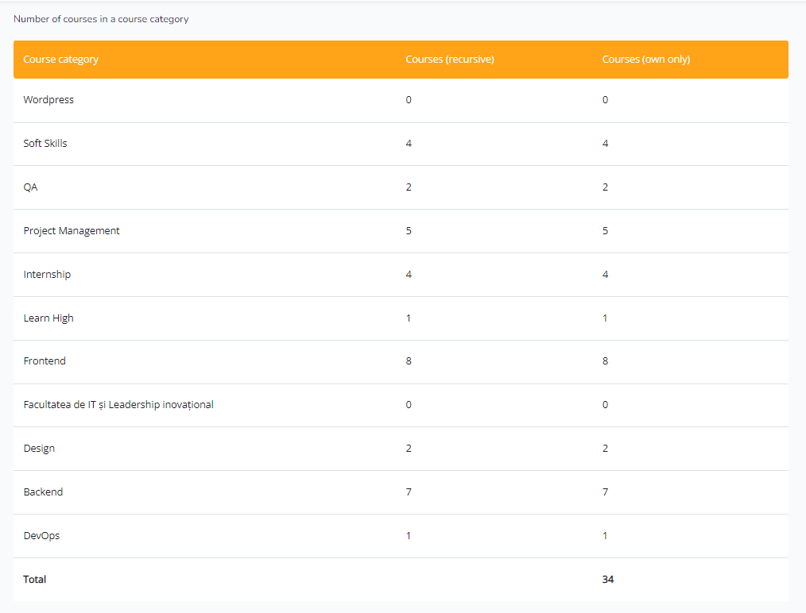

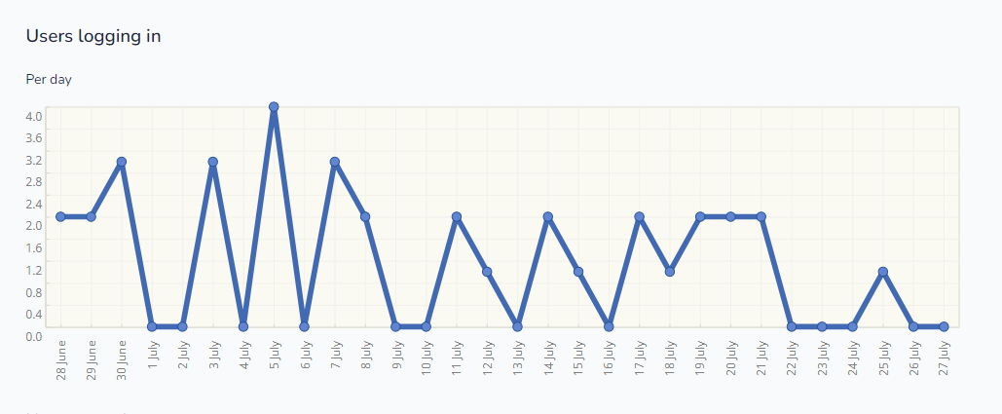

**Report Doit**

**Profiles assigned: 68**

**Tasks: 60**

**Companies: 5**

**Quantitative Report**

| *Company name:* | **Power IT** |
| --- | --- |
| *Address / Location:* | 42 Albișoara st., bldg.1, ap.67, Chisinau,  Republic of Moldova |
| *Contact phone:* | +37379592354 |

| *E-mail:* | Michael.gutu@powerit.dev | |
| --- | --- | --- |
| *Name of training:* | www.learnit.md www.doit.md | |
| *Training is realized (from month – to month):* | June 2023 – July 2023 | |
| ***I. Number of participants in the training*** | **Total: 270** | |
| *By groups - participants who attended the training* | *Youth/Persons up to 25 years old* |  |
| *Women* |  |
| *Men* |  |
| *Adults* |  |
| *Excluded groups\** |  |
| ***II. Number of participants who applied for a job*** | **Total: N/A** | |
| *By groups - participants who applied for a job* | *Youth/Persons up to 25 years old* |  |
| *Women* |  |
| *Men* |  |
| *Adults* |  |
| *Excluded groups\** |  |
| ***III. Number of participants who report ability to apply/use new economic opportunities***  ***(graduates)*** | **Total: N/A** | |
| *By groups – participants who will use new skills* | *Youth/Persons up to 25 years old* |  |
| *Women* |  |
| *Men* |  |
| *Adults* |  |
| *Excluded groups\** |  |
| ***IV. Number of participants who found a job*** | **Total: N/A** | |
| *By groups - participants who have been employed* | *Youth/Persons up to 25 years old* |  |
| *Women* |  |
|  | *Men* |  |
| *Adults* |  |
| *Excluded groups\** |  |
| ***V. Total amount of net additional income earned by employees\*\**** | ***Total Net CHF:*** *N/A* | - |
|  |  |
| ***Total Net MDL: N/A*** |  |
|  |  |  |
|  |  |  |

| **Age** | Statistics based on the questionnaire (73 students) |
| --- | --- |
| **<20** | 12 |
| **20-25** | 40 |
| **25+** | 21 |

| **Gender** | Statistics based on the questionnaire (73 students) |
| --- | --- |
| **Female** | 45 |
| **Male** | 28 |

| **Living Place** | Statistics based on the questionnaire (73 students) |
| --- | --- |
| **Village** | 28 |
| **City** | 45 |

| **Working Status** | Statistics based on the questionnaire (73 students) |
| --- | --- |
| **Have a job** | 51 |
| **Don’t have a job** | 22 |

| **Working Types** | Statistics based on the questionnaire (73 students) |
| --- | --- |
| **Freelance** | 27 |
| **Part-time** | 3 |
| **Full-time** | 22 |
| **Don’t work online** | 21 |

| **Future plans on IT sector** | Statistics based on the questionnaire (73  students) |
| --- | --- |
| **Plan to start a career** | 35 |
| **Want to continue** | 38 |
| **Want to start a career** | 0 |

| **Have you applied for a job/internship in Learn IT or Do IT?** | Statistics based on the questionnaire (73 students) |
| --- | --- |
| **Yes** | 51 |
| **No** | 22 |

| **Have you managed to get hired via the opportunities placed in Learn IT or Do IT?** | Statistics based on the questionnaire (73 students) |
| --- | --- |
| **Yes** | 36 |
| **No** | 19 |
| **In the process** | 18 |

| **Was the information available on the platforms Learn IT and Do IT useful and applicable?** | Statistics based on the questionnaire (73 students) |
| --- | --- |
| **Yes** | 70 |
| **No** | 3 |

Name and Surname:

**Excluded group*:**

1. *Rural youth*
2. *Rural women*
3. *Rural man*
4. *Returning migrants*
5. *Ethnic minorities*
6. *People with disabilities*

***Total amount of net additional income earned by employees**:***

1. *Freelance income*
2. *Full salary employment*
3. *Part-time salary employment*